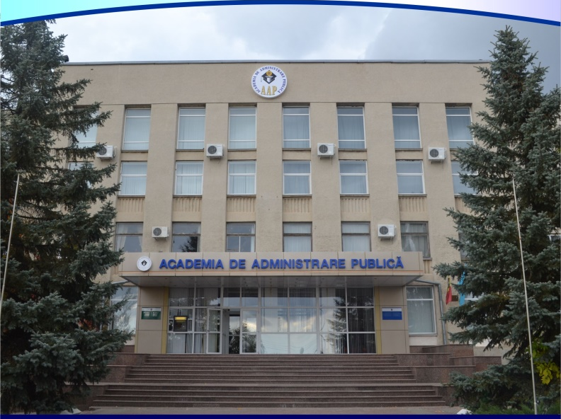

THE ACADEMY OF PUBLIC ADMINISTRATION

IS INVITING REPRESENTATIVES FROM THE ACADEMIC ENVIRONMENT, PUBLIC ADMINISTRATION AND EXPERTS FROM THIS AREA TO PARTICIPATE AT

the International Scientific – Practical Conference
„THEORY AND PRACTICE OF PUBLIC ADMINISTRATION”
(TPPA 2021)

Friday, May 21, 2021

in online format

Workshops

Workshops |  | Name, address and phone of the responsible person
Workshop 1 | Modernization of public administration in the context of European integration | Tincu Violeta,  tel. (+373) 69189377  e-mail: tivioleta@mail.ru
Workshop 2 | Current issues of political science and European course of the Republic of Moldova | Popovici Angela,  tel. (+373)-22-28-48-38  mob. (+373) 79404482  e-mail:  angela.popovici2000@gmail.com
Workshop 3 | Theoretical and practical issues regarding the state law and public administration modernization | Goriuc Silvia,  tel. (+373) 79402810  e-mail: silvia.goriuc@rambler.ru
Workshop 4 | Trends in public management in the context of creating a knowledge-based administrative system | Tofan Tatiana,  tel. (+373) 78884840  e-mail: tatianatofan@yahoo.com
Workshop 5 | Professional development of staff: theory and practice | Ciutac Irina  tel.(+373) 78884809  e-mail: ddp@aap.gov.md
Working languages of the conference: Romanian, Russian and English

Conference opening - 10.00

in online format

Requirements for conference materials, fee, application form (Annex 1, 2, 3)

Annex 1
REQUIREMENTS FOR THE INTERNATIONAL SCIENTIFIC-PRACTICAL
CONFERENCE MATERIALS

ON MAY 21, 2021

"Theory and Practice of Public Administration"
(TPPA – 2021)

The paper should be typed (MS Word, Times New Roman) and presented on a CD-ROM, USB flash drive or to the e-mail address (depending of the chosen workshop).

Papers submitted by master students should also be reviewed by their scientific coordinator.

Structure of the article:
- title (capital letters);
- author’s last name and first name, degree and academic title, workplace (institution) and position;
- summary/ abstract (English or French): 5-8 lines, font-10 pt, 1,0 interval;
- keywords (7-10 notions and scientific terms used in the article)
- text of the article: interval-1,5, font-14, fields: left-3,0; right-1,5; up, down- 2,5 (format A4-portrait);

References:
Figures, images and tables should be put after the reference in the text, or on separate pages, indicating their place, if the author has no technical means.
Images should be of good quality, JPEG standard.
Number and legend should be placed under the figure or image.
Tables should have numbers and title. It’s not allowed the duplication of the material in the text, tables and figures.
References within the text should be between square brackets.
The references will be presented in numerical sequence, in alphabetical order.
Bibliography should be written as follows:
- normative acts: name of the act, number, date of approval, source of publication
- journals and articles: name(s) of the author(s), title of the article, title of the journal, accepted abbreviations, publication year, volume, number, first and last page;
- books: name(s) of the author(s), complete title, publisher, editing place, publication year, number of pages.

Mentions:

- if there are 2 authors, then must be sent 2 photos (attaching the photos to the paper is mandatory);
- if you fail to frame the picture, you can send an e-mail;
- it is necessary to delimit the summary from the text through some free rows.

The deadline for presenting the information and materials:
- Registration form (Annex 2) – till April 9, 2021;
- Materials for publication – till April 23, 2021;
- Conference materials will be published with a volume of up to 8 standard pages (up to 14,400 characters, no intervals).

Papers which are not related to the topic, are not in accordance to the layout or are submitted after the deadline will not be considered.

Annex 2
PARTICIPATION FEE AND PUBLICATION OF THE MATERIALS

Participants will be registered only if they pay the conference fee.

The conference fee is:
- For people from other educational institutions – 250 MDL
- For people from abroad – 50 EUR*
The participation fee will be paid through a transfer or at the cash desk of the Academy of Public Administration – till May 14, 2021.

Banking requisites of the Academy of Public Administration for the transfer of the participation fee
Institution: Academy of Public Administration
Legal address: MD-2070, Chisinau, 100, Ialoveni street.

For transfers in EURO:
Correspondent bank: Landesbank Baden – Wurttemberg, Germany SOLADESTXXX
Account with correspondent bank: 2808114
Beneficiary bank: BC Moldindconbank S.A., Moldova/ SWIFT: MOLDMD2X
Beneficiary customer: Academy of Public Administration, 100, Ialoveni street
Chisinau, MD-2070
SWIFT: MOLDMD2X306
EURO: IBAN: MD97ML000000002251606232

For transfers in Lei MD
Instituția: Academia de Administrare Publică
Adresa juridică: MD-2070, mun. Chișinău, str. Ialoveni, 100
Banca beneficiarului: BC Moldindconbank S.A. filiala Telecentru
Cod bancar: (BIC) MOLDMD2X306
Cod IBAN (în MDL): MD97ML000000002251606232
Cod fiscal: 1007600004873

Phone: (+373 22) 72-38-66; (+373 22) 28-40-84; fax.: (+373 22) 28-48-71.

Annex 3
APPLICATION FORM
The international scientific – practical conference
,,Theory and practice of public administration” (TPPA-2021)

May 21, 2021

The correctness of the registration form is important for completing the certificates.

TITLE OF THE PAPER
AUTHOR / 2 AUTHORS  (NAME/ SURNAME, PROFESSION) | 1.
 | 2.
SCIENTIFIC DEGREE
scientific-teaching title
INSTITUTION
WORKSHOP (remains only the chosen option,  ex. workshop II) | Workshop I: Workshop II: Workshop III:  Workshop IV: Workshop V:
ADDRESS | Name and surname:____________________________________,  Country _______________________________________  City ________________________________________  Str. ______________________________________, Nr. _______,  Bl. ________, Ap. ___________.  Zip code __________________
Phone (mandatory):
E-MAIL (mandatory):
I paid the fee: ________ receipt: Nr. _________________ from the date ________________
OBSERVATIONS

_______________
(date)

